***COAL LAB #10***

***18F-0358_Mehdi Raza***

***Q#1:-***

INCLUDE Irvine32.inc

.data

space db " ",0

.code

main PROC

call Randomize

call Rand1

call Rand2

exit

main ENDP

Rand1 PROC

mov ecx,10

L1:

call Random32

call WriteDec

mov al,space

call WriteChar

call WriteChar

call WriteChar

loop L1

call Crlf

ret

Rand1 ENDP

Rand2 PROC

mov ecx,10

L1:

mov eax,100

call RandomRange

sub eax,50

call WriteInt mov al,space

# call WriteChar

# call WriteChar

# call WriteChar

# loop L1

# call Crlf

# ret

# Rand2 ENDP

# end main

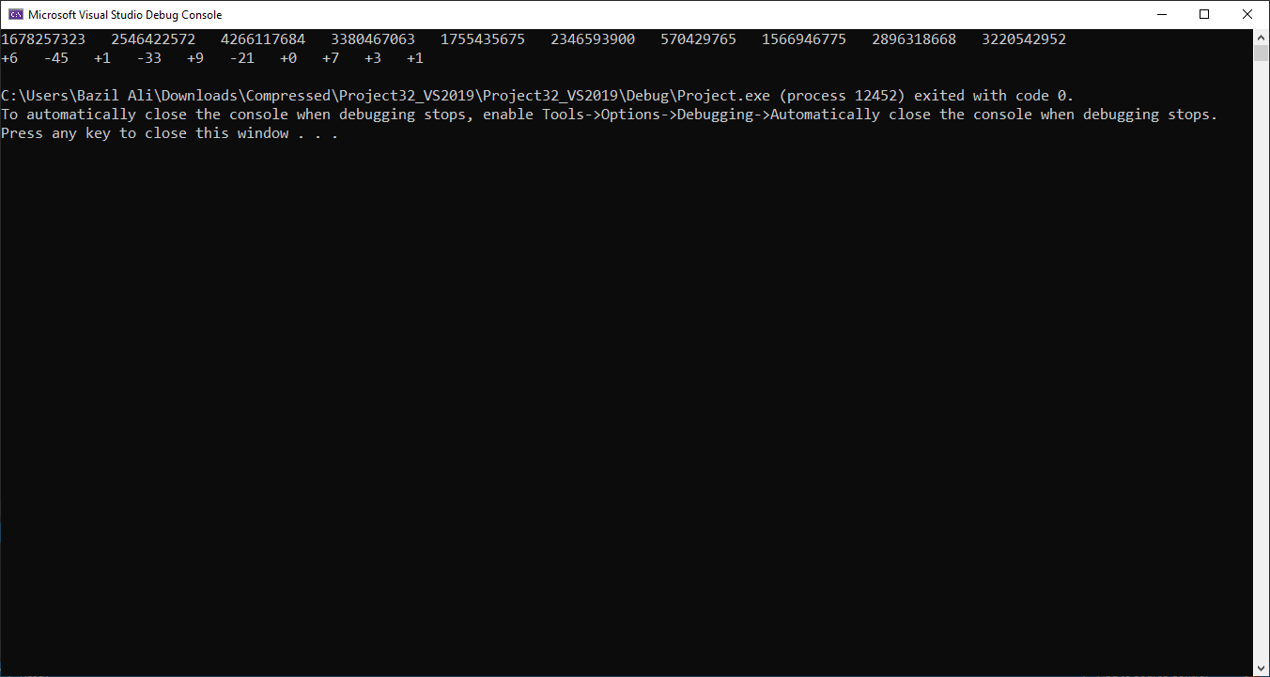

***Q#2***

INCLUDE Irvine32.inc

.data

string DB "This is the source string",0

.code

main PROC

mov ecx,lengthof string-1

mov esi,0

L1:

movzx ax,string[esi]

push ax

inc esi

loop L1

mov ecx,lengthof string-1

mov esi,0

L2:

pop ax

mov string[esi],al

inc esi

mov al,string

loop L2

mov edx,offset string

call WriteString

exit

main ENDP

END main